**Phase 2: Org Setup & Configuration**

**1.Salesforce Edition & Org Setup:**

* **Salesforce Edition**: Salesforce Developer Edition (suitable for prototyping & testing).
* **Dev Org Setup**: Created a dedicated Developer Org for **MediConnect CRM**- “*Smart Hospital Appointment & Patient Management”.*

**2. Company Profile Setup:**

* **Defines company information**: Name, Address, Currency, Locale, Time Zone, Primary Contact.
* Forms the base of org-wide settings.
* **Setup:**
* **Org Name**: *MediConnect CRM Pvt. Ltd.*
* **Primary Contact**: Admin email.
* **Currency**: INR (₹)
* **Time Zone**: IST (GMT+5:30).
* **Locale & Language**: English (India).

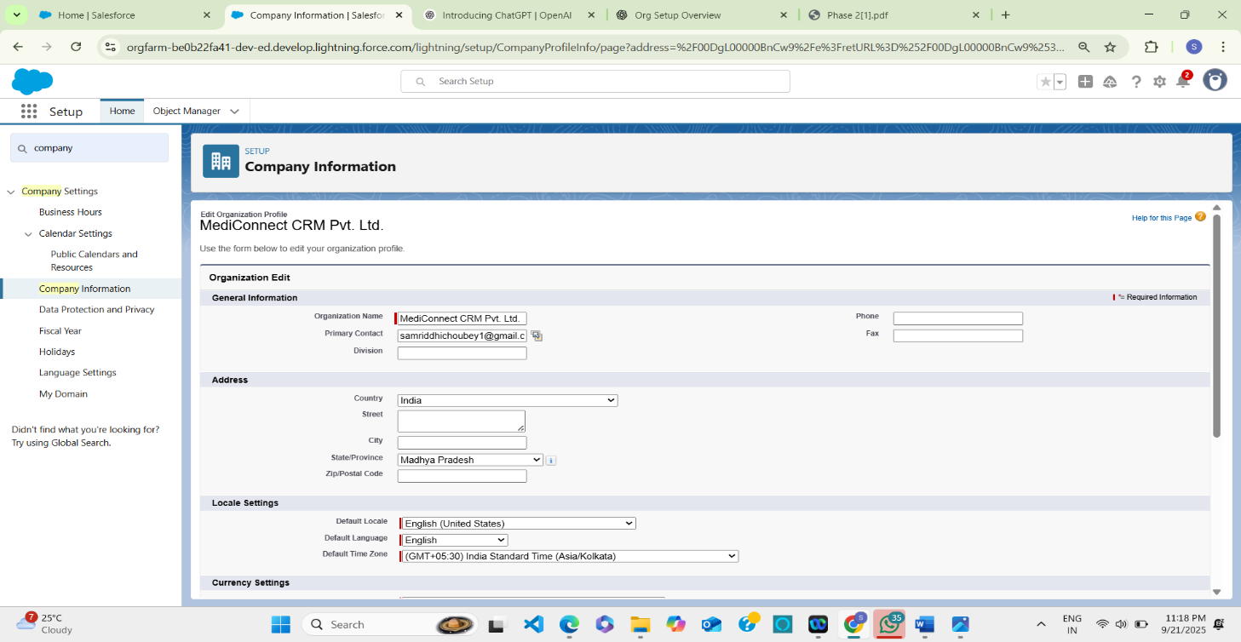

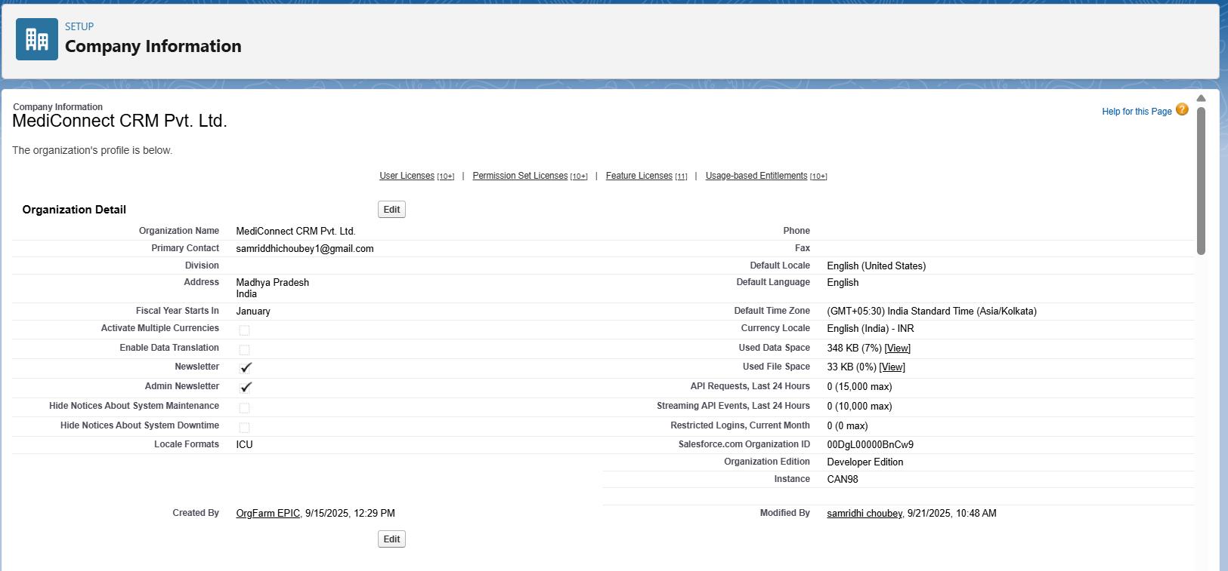

**3. Business Hours & Holidays:**

* **Hospital Working Hours** (e.g., 9:00 AM – 8:00 PM IST)
* **Holiday**: Sunday, National holidays (Republic Day, Independence Day etc.)

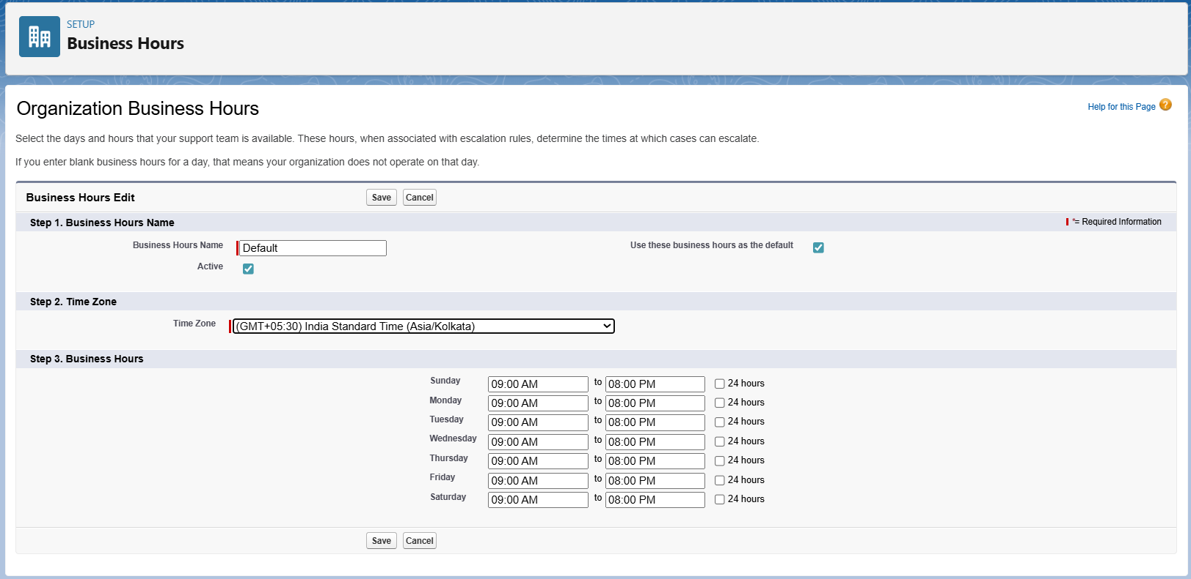

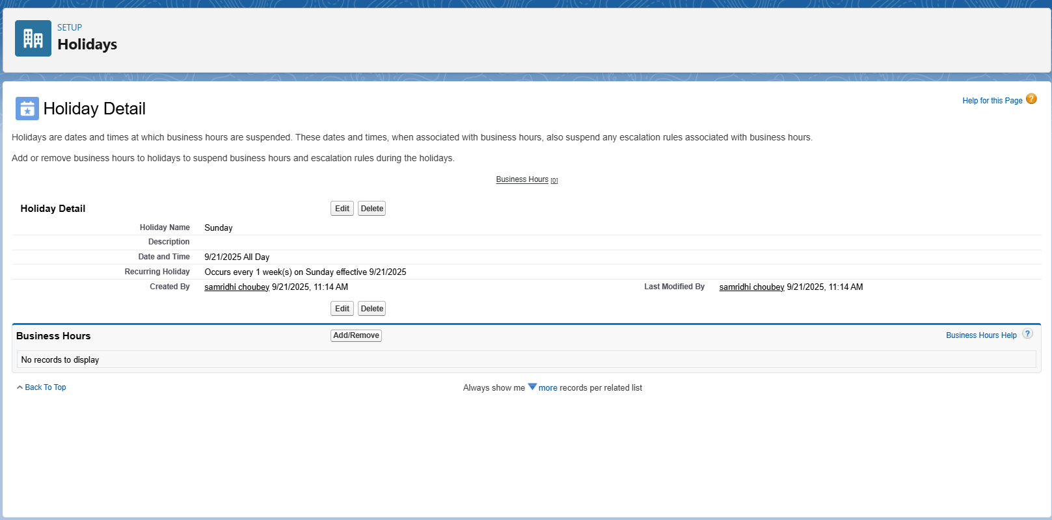

**Note: For admin/billing/support cases** → set **9 AM – 8 PM** business hours. **For emergency/critical cases** → set **24×7 business hours**.

**4. Fiscal Year Setting**

**Fiscal Year =** financial calendar of the organization, used for reporting & forecasting.

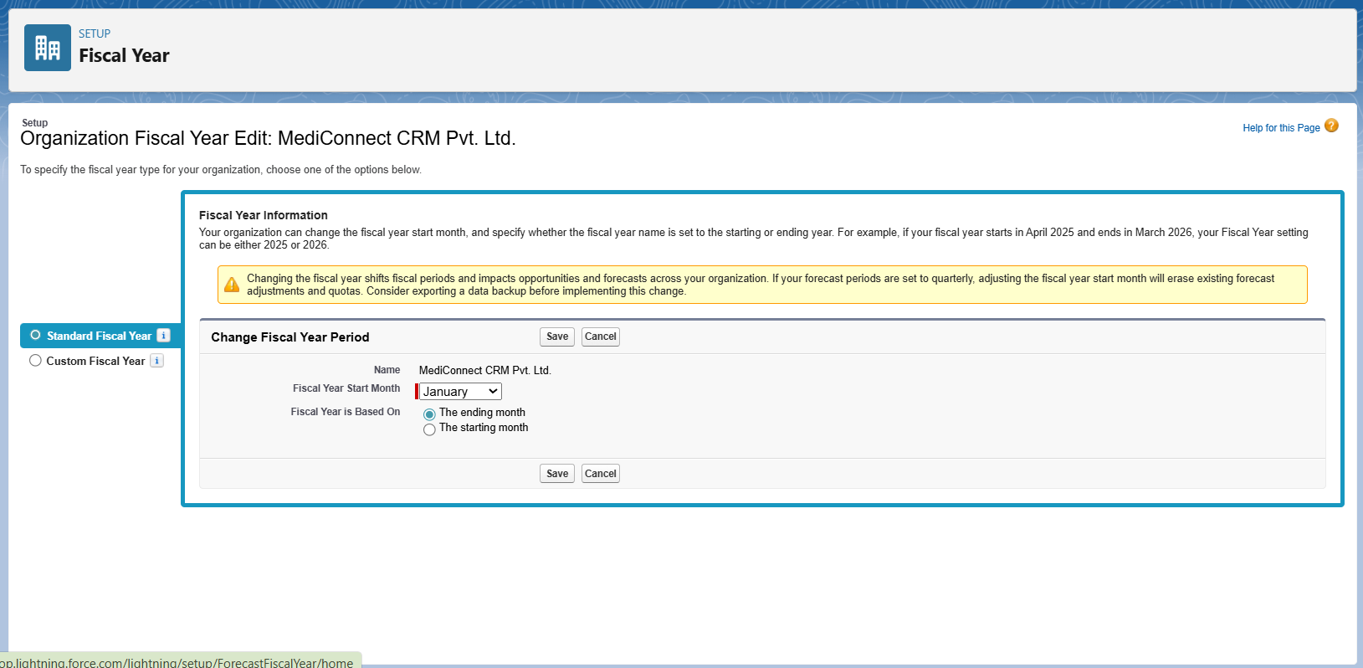

Two options:

1. **Standard Fiscal Year** → Always based on the Gregorian calendar (Jan–Dec, Apr–Mar, etc.).
2. **Custom Fiscal Year** → You define custom periods (e.g., 4-4-5 weeks per quarter, or 13 periods per year).

**5. User Setup, Licenses & Profiles:**

To create Salesforce users with correct licenses and assign them appropriate profiles & roles according to MediConnect CRM’s hierarchy (Admin, Hospital Manager, Doctor, Nurse, etc.).

For example, we create a user *Dr. Rajul Mehta*

Steps to follow:

**Step1**: Navigate to User Setup

* Setup → Users → Users → *New User*

**Step2**: Enter Basic Information

* **Name**: Dr. Rohan Mehta
* **Email**: mehta1@gmail.com
* **Username**: rohan.mehta@mediconnect.com.crm
* **Alias**: rmehta
* **Nickname**: auto-generated

**Step3**: Select User License

**User License**: *Salesforce*

Reason: Head Doctor requires standard CRM features (access to Doctors, Patients, Appointments).

**Step 4:** Assign Profile

* **Profile**: *Head Doctor Profile*
  + Permissions:
    - Read/Edit on **Doctors** (for junior doctors).
    - Read/Edit on **Patients** (to monitor all patients under his doctors).
    - Read on **Appointments** (visibility of schedules).
    - No access to **Billing**.

**Step 5:** Assign Role

* **Role**: Head Doctor
  + **Reports To**: Hospital Manager
  + Hierarchy:  
    Admin → Hospital Manager → **Head Doctor** → Doctor → Nurse

**Step 7: Save User**

* Dr. Mehta receives welcome email to set login password.

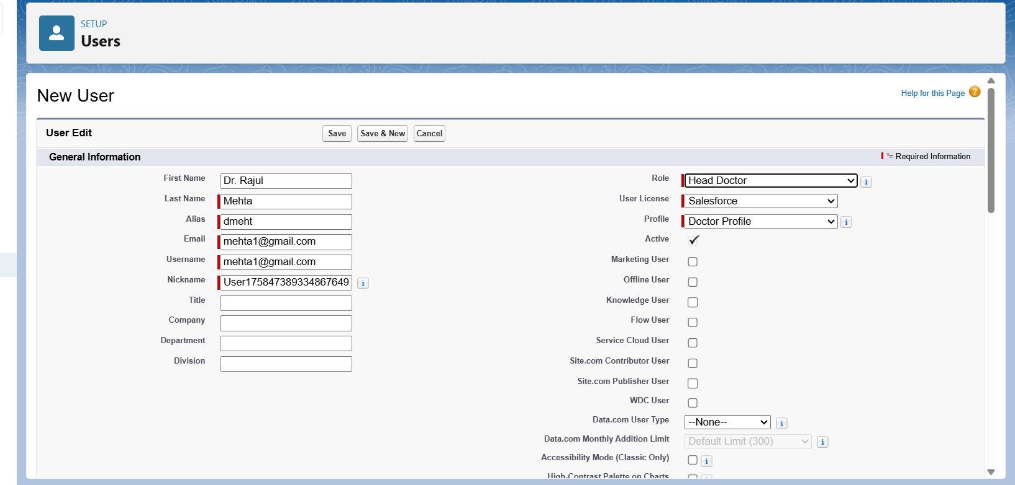

Profiles in MediConnect CRM:

* System Administrator (standard)
* Hospital Manager (custom)
* Head Doctor (custom)
* Doctor (custom)
* Nurse (custom)
* Receptionist (custom)
* Billing Officer (custom)
* Pharmacist (custom)
* Patient (custom, portal)

| **User Type** | **License** | **Profile** | **Role** |
| --- | --- | --- | --- |
| Admin | Salesforce | System Administrator | Admin |
| Doctor | Salesforce | Doctor Profile | Doctor |
| Receptionist | Salesforce Platform | Receptionist Profile | Receptionist |
| Billing Officer | Salesforce / Platform | Billing Officer Profile | Billing Officer |
| Patient | Customer Community | Patient Profile | Patient |

Demo users for MediConnect CRM following same steps:

| **User Name** | **Role** | **Profile** | **License** | **Email** |
| --- | --- | --- | --- | --- |
| Admin (You) | Admin | System Administrator | Salesforce | [admin@mediconnect.com](mailto:admin@mediconnect.com) |
| Mr. Arora | Hospital Manager | Hospital Manager | Salesforce | [arora@mediconnect.com](mailto:arora@mediconnect.com) |
| Dr. Mehta | Head Doctor | Head Doctor Profile | Salesforce | [mehta@mediconnect.com](mailto:mehta@mediconnect.com) |
| Dr. Sharma | Doctor | Doctor Profile | Salesforce | [sharma@mediconnect.com](mailto:sharma@mediconnect.com) |
| Nurse Priya | Nurse | Nurse Profile | Salesforce | [priya@mediconnect.com](mailto:priya@mediconnect.com) |
| Anjali | Receptionist | Receptionist Profile | Salesforce | [anjali@mediconnect.com](mailto:anjali@mediconnect.com) |
| Mr. Verma | Billing Officer | Billing Officer | Salesforce | [verma@mediconnect.com](mailto:verma@mediconnect.com) |
| Rahul | Pharmacist | Pharmacist Profile | Salesforce | [rahul@mediconnect.com](mailto:rahul@mediconnect.com) |

**6. Roles & Role Hierarchy:**

Roles: A **Role** defines **where the User sits in the hierarchy** → i.e., who can see whose records.  
It is mainly about **record-level access** (visibility).

* Navigate: Setup -> Users -> Roles -> Create New Role

Define Role Hierarchy in MediConnect CRM:

Admin

┌──────┴────────┐

Hospital Manager Billing Officer

│ |

┌──────┴──────┐ Pharmacist

Head Doctor Receptionist

│

┌───┴─────┐

Doctor Nurse

│

Patient (Portal Users)

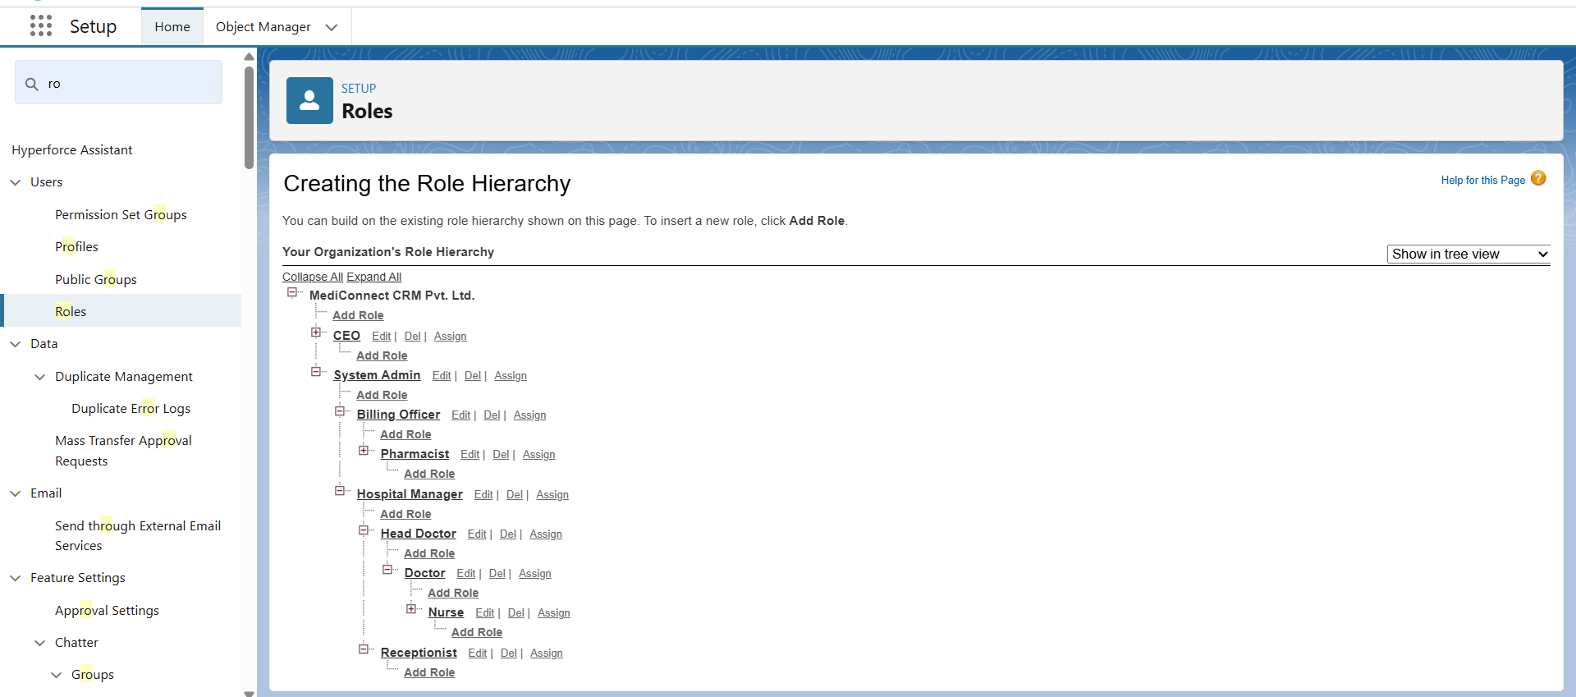

**🔹 Benefits of this Richer Hierarchy**

* **Admin** → sees everything.
* **Hospital Manager** → sees doctors, nurses, receptionists data but not billing.
* **Head Doctor** → can see all junior doctors’ patients.
* **Doctor** → can see only their patients.
* **Nurse** → can see only their doctor’s patients.
* **Receptionist** → can see only appointments.
* **Billing Officer** → can see only billing data.
* **Pharmacist** → can see prescriptions.
* **Patient** → sees only their own data.

**7. Permission Sets:**

Permission Sets = extra access you give only to selected users.

**🔹 Example Scenario**

* **Doctor Profile** → normally has access only to Patients + Appointments.
* But let’s say you want **one senior doctor** (Dr. Rajul Mehta) to also see **Billing reports**.
* Instead of cloning Doctor Profile, you create a **Permission Set: Billing Read Access** and assign it to Dr. Rajul Mehta.

**Step-by-Step: Create Permission Set**

1. Go to Setup → Permission Sets → New
   * Label: **Billing Read Access**
   * API Name: **Billing_Read_Access**
   * User License: *leave default (Salesforce)*
2. Add Object Permissions
   * Click **Object Settings → Billing**
   * Grant:
     + Read
     + (this means view-only access to Billing records)
3. Assign Permission Set to User
   * Go to **Users → Dr. Rajul Mehta** → scroll down → **Permission Set Assignments → Edit Assignments**.
   * Add **Billing Read Access**.

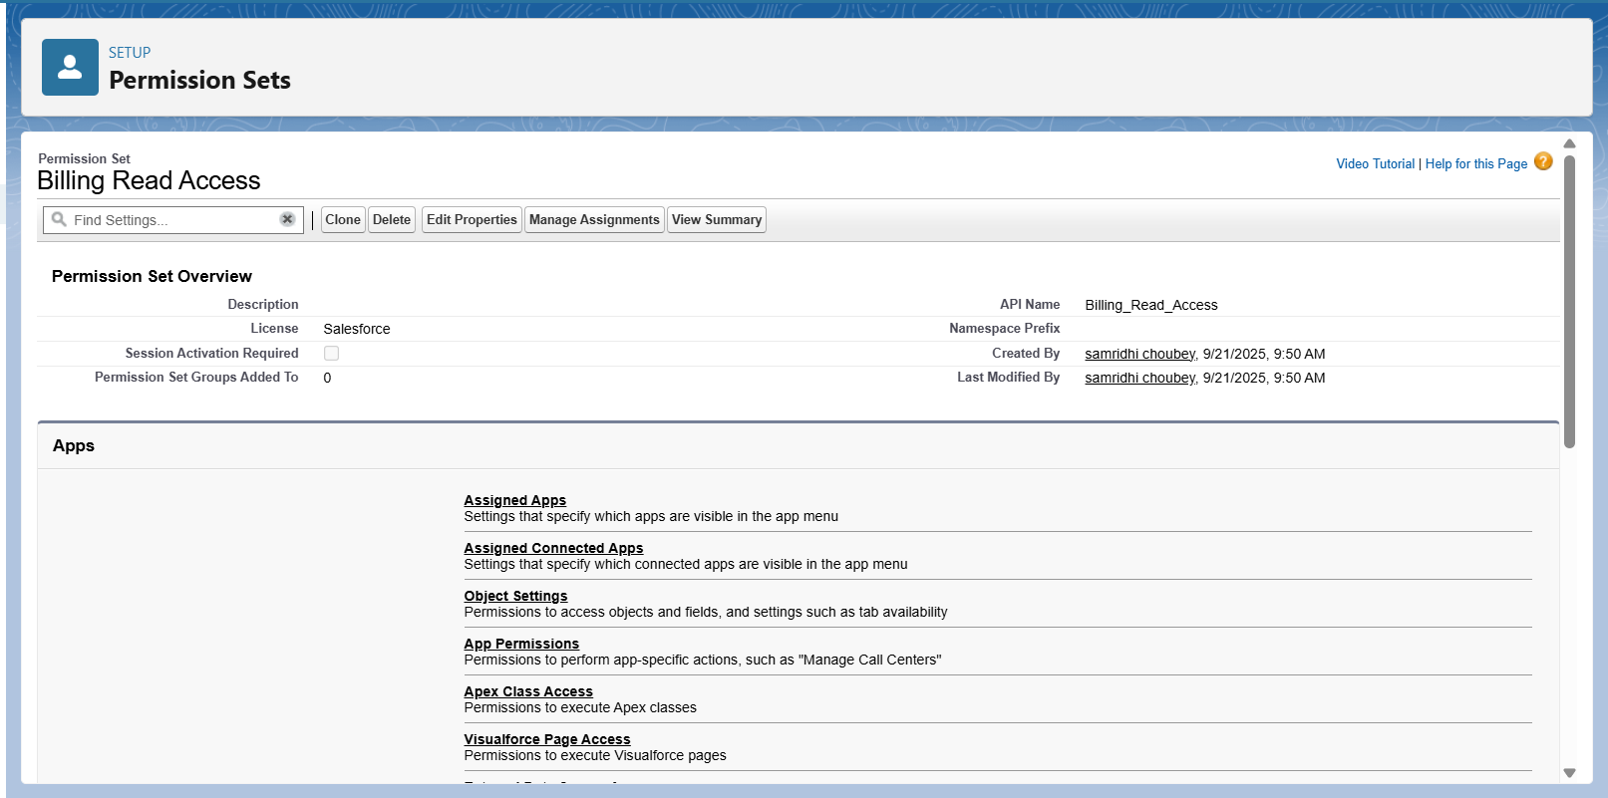

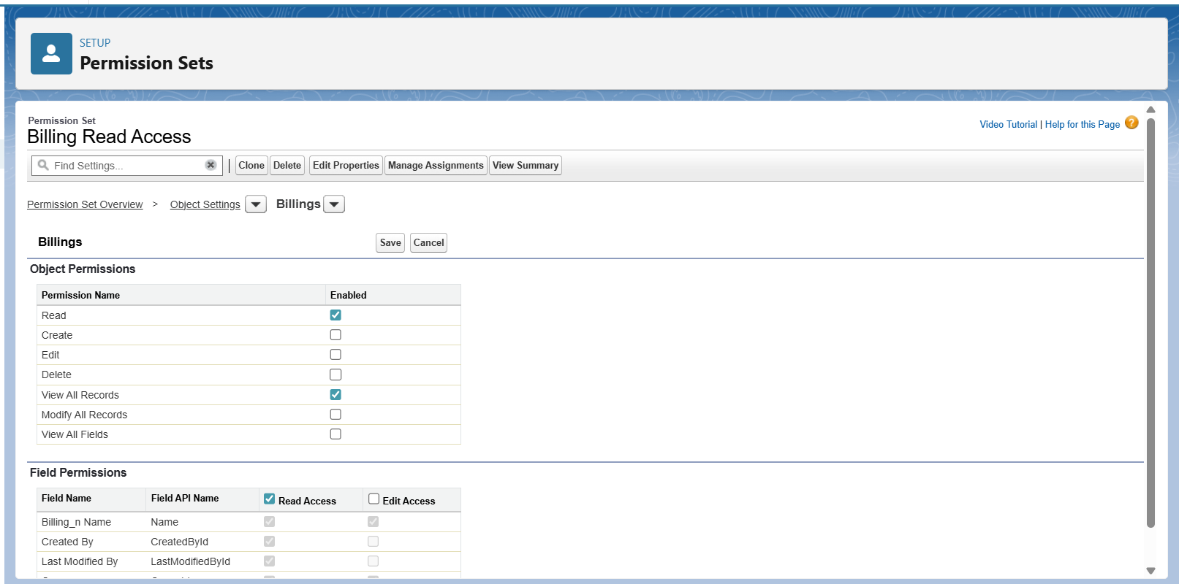

**8. Organization-Wide Defaults (OWD)**:

• Will be configured in Phase 3 after objects (Job Post, Candidate, Application, Interview) are created.

**9. Sharing Rules:**

• Will be configured in Phase 3 after objects are created**.**

**10.Login & Access Policies:**

• Enable: Force re-login after session timeout

• Save

**11.Sandbox Usage & Deployment Basics:**

• Sandbox is used for testing automation and Apex before deployment.

• Deployment from Sandbox → Production will be done using Change Sets or SFDX.

|  |  |  |
| --- | --- | --- |
|  |  |  |
|  |  |  |  |
|  |  |  |  |
|  |  |  |  |
|  |  |  |  |